**St Luke, Torquay**

**Christ the King**

**Sunday Bulletin for Week beginning 21st November, 2021**

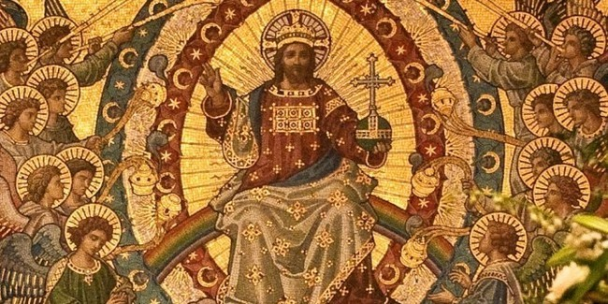

**Christmas Fair**

Saturday 27th November,

10am-2.00pm

Stalls, games, refreshments, and by popular demand the Vicar’s auction!!!

**If you can help in any way with the Christmas Fair, please speak with Cilla, or contact the Parish Secretary, Trish.**

**Advent with St Francis**

“Join St Francis for four adventures on the road to Christmas.”

Thursdays in Advent at 11am. Beginning on 2nd December

**Shared Christmas Lunch**

Saturday 11th December, 12.30pm

at the Livermead House Hotel.

**Continuing to support the Community Food Banks.**

We are continuing to collect and offer donations to the Community Food Banks. If you would like to donate food it can be left in the box which is in church.

**Rotas**

Rota sheets for church flowers, and for refreshments are in church. Please sign up if you are able to help with these activities. If you would like to join the rota for readers or those who lead the prayers please contact the Parish Secretary, Trish.

**Services this week**

**@ St Luke**

**Sunday 21st November**

**Christ the King**

11.00am Holy Communion

6.00pm Evensong (B.C.P)

**Thursday 25th November**

10.15am, Holy Communion

**Sunday 28th November**

11.00am Holy Communion

6.00pm Evensong (B.C.P)

**Those attending church services and events are encouraged to continue to observe social distancing, the wearing of masks/face coverings and hand-sanitising.**

**Keeping in Touch**

Send us your email address if you would like to receive the weekly bulletin and updates.

Follow the Parish on Facebook: St Luke’s Parish Church Torquay

***Revd/Fr. Peter March 01803 312754*** [***p.j.march@hotmail.co.uk***](mailto:p.j.march@hotmail.co.uk)

***Revd/Fr. Peter Jackson 07443 294480*** [***pedro88j@aol.com***](mailto:pedro88j@aol.com)

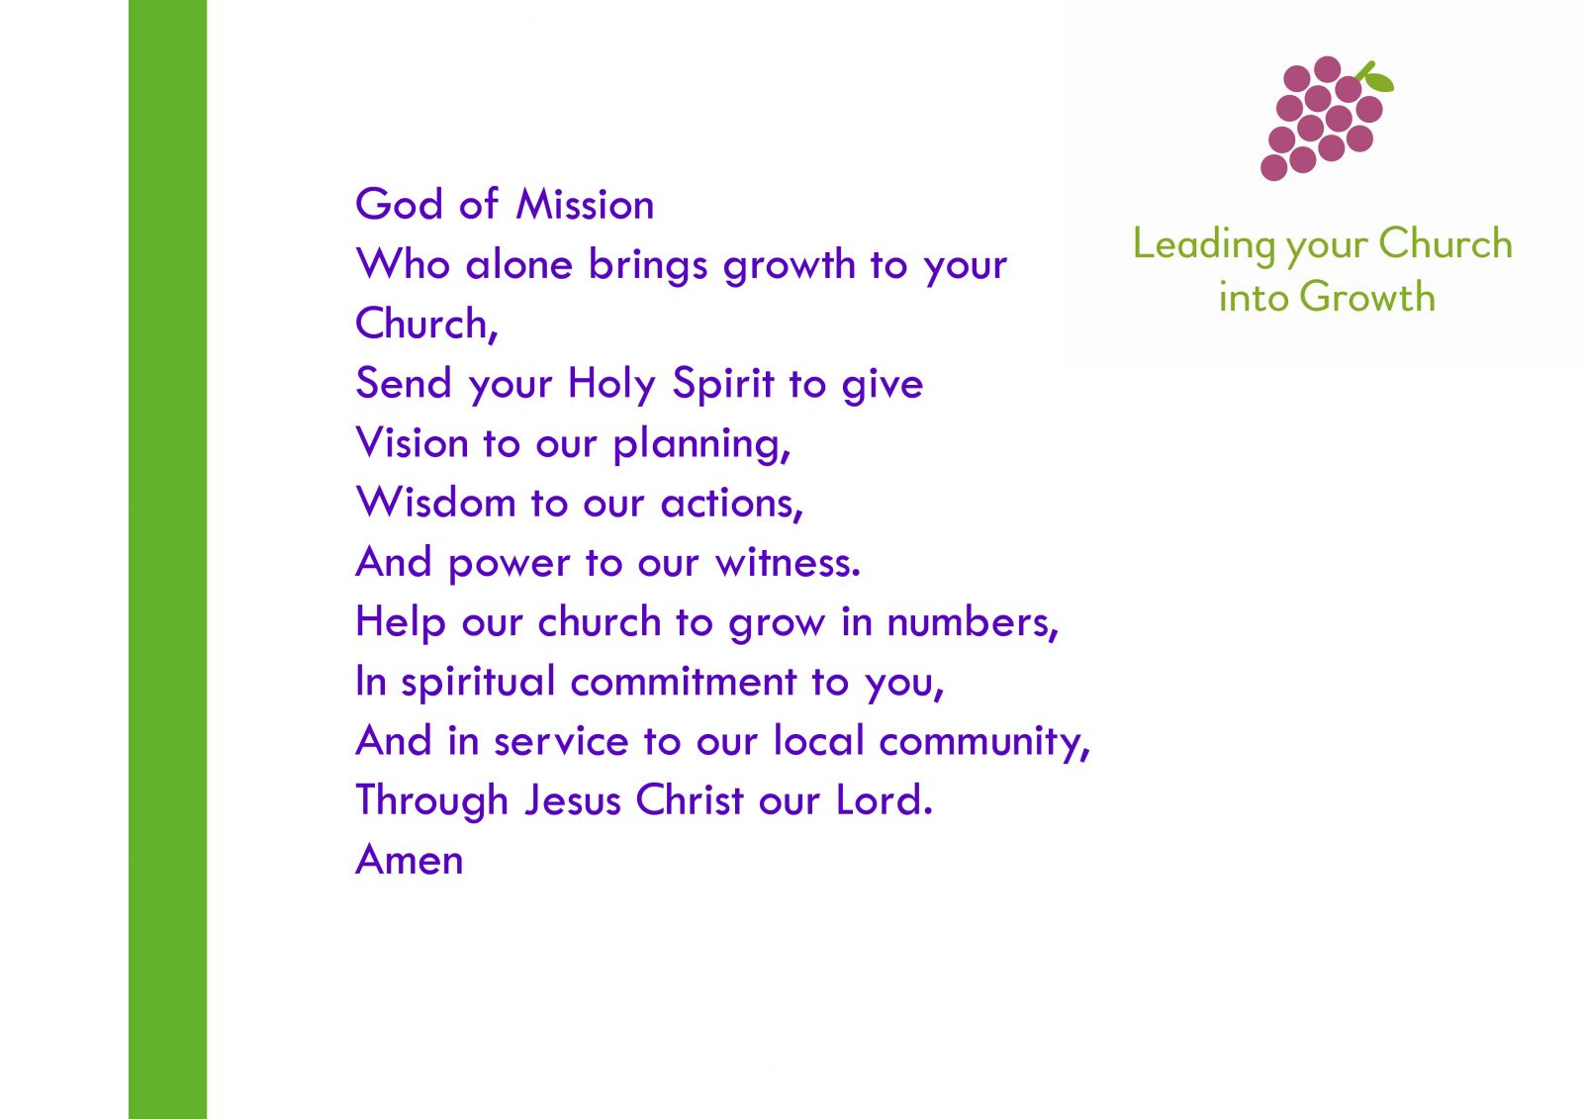

**Christ the King**

Collect

Eternal Father,

whose Son Jesus Christ ascended to the throne of heaven

that he might rule over all things as Lord and King:

keep the Church in the unity of the Spirit and in the bond of peace,

and bring the whole created order to worship at his feet;

who is alive and reigns with you,

in the unity of the Holy Spirit,

one God, now and for ever. **Amen.**

Readings

Daniel 7:9-10, 13, 14

Psalm 93

Revelation 1:4-8

John 18:33-37

Post Communion Prayer

Stir up, O Lord,

the wills of your faithful people;

that they, plenteously bringing forth the fruit of good works,

may by you be plenteously rewarded;

through Jesus Christ our Lord. **Amen**

**November at a glance**

1st All Saints’ Day

2nd All Souls Day

11th St Martin of Tours

14th Remembrance Sunday

21st Christ the King

28th Advent Sunday

30th Andrew the Apostle

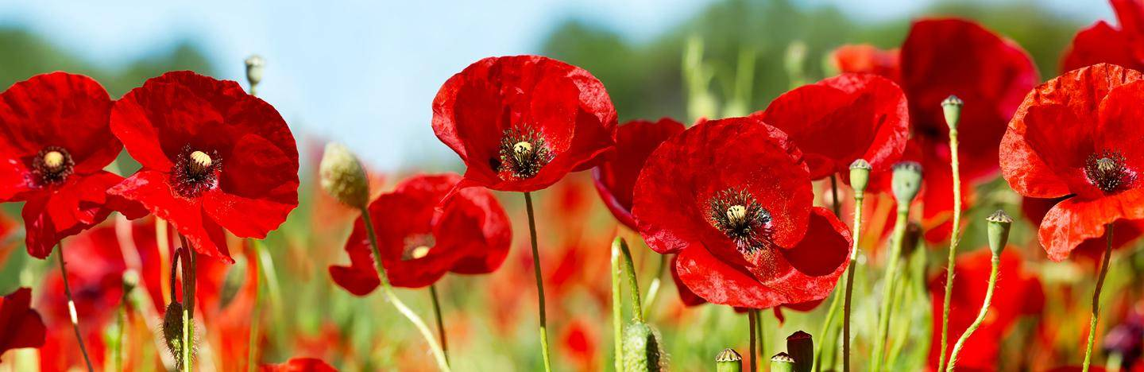

**Time to Read and Pray with**

**Scripture each day.**

Here are the Gospel readings set for each day this week. You might like to take the time to read them and pray with them.

**Sunday,** John 18:33-37

**Monday**, Luke 21:1-4

**Tuesday**, Luke 21:5-11

**Wednesday**, Luke 21:12-19

**Thursday**, Luke 21:20-28

**Friday**, Luke 21:29-33

**Saturday,** Luke 21:34-36